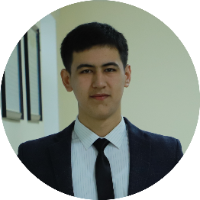

Ravshanbekov Shohrux

Android developer

Student of Tashkent University of Information Technologies. Junior Android developer.



[ravshanbekov001@gmail.com](mailto:ravshanbekov001@gmail.com)

+9989996349564

Andijan, Uzbekistan

github.com/Ravshanbekov001

**

t.me/Andr0idDevel0per

# EDUCATION

## Programm engineering

Tashkent University of Information Technologies / Uzbekistan Fergana

## Android programming

Codial Training Center / Uzbekistan Fergana

# WORK EXPERIENCE

## No

# SKILLS

Android

Kotlin

Java

Room

MVVM

# LANGUAGES

Uzbek

*Native or Bilingual Proﬁciency*

Russian

*Professional Working Proﬁciency*

English

*Elementary Proﬁciency*

# INTERESTS

Android development

Computer technologies

IT

Electronics